RAID STRUCTURE

Raid 2 disks, considering a disk with 100 000 Mean Time To Failure (MTTF) and 10 hours Mean Time To Repair (MTTR), Mean To Time Data Loss (MTTDL)?

MTTF (mean time to failure) = 100 000 hours
Probability to failure = 1/ MTTF

MTTDL (mean time to data loss) = 1 / probability of data loss (dl)

PDL (probability to data loss) = (P(f1) + P(f2)) * (P(f1/2) * MTTR) = (10^-5 + 10^-5) * (10^-5 * 10) = 2 * 10^-9

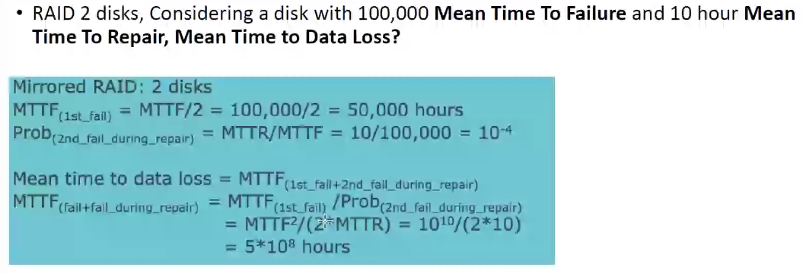
MTTDL = 1/(2 * 10^-9) = 5 * 10^8 hours

